# Better Conversations Live: Overview Document & Questions

Imagine having an early night because you have a headache. You pop a paracetamol out its foil pack and gulp it down with some water then settle down assuming it will pass by morning. Now, imagine waking up in the middle of the night, on the floor. Unusual, but you’ll get up and it will make a funny story tomorrow. But, weirdly you cannot get up, you cannot move your right arm or leg. In panic and confusion you call for help but no words emerge, just a strange noise. When someone finally hears you and comes into the room you can see the panic on their face and you try to tell them you fell out of bed but they clearly are not understanding you, and you are not able to understand them either. Horrific. This nightmare is what can happen if you experience a stroke (a bleed or clot in the brain). Damage to the area of the brain that controls language leads to aphasia. 100,000 people a year, or 1 person every 5 minutes, experiences stroke in the UK with 13,000 of those people experiencing long-term aphasia (Stroke Association, 2018). Aphasia leads to a loss of friendships and social support (Hilari & Northcott, 2017) and a greater incidence of major depression (Kauhanen et al., 1999) reduced social contacts, an inability to return to work and overall poorer quality of life than their non-aphasic counterparts (Hilari, 2011; Manning, Hickey, MacFarlane, & Franklin, 2019). Further a person with weaker social relationships (i.e. less friends and social support) is at 50% greater risk of dying than their counterpart with strong social networks (Holt-Lunstad & Smith, 2012). Thus aphasia is not just a long-term problem for the individual; it is also a long-term problem for family, friends, the health service and social care.

Speech and language therapists are the predominant health care professionals trained to treat and support people with aphasia. There is a breadth of literature demonstrating how targeting specific linguistic deficits can change performance on formal tests of these skills, but there is less clear evidence to support the presumption that improvement on formal tests carries over into everyday conversation (Carragher, Conroy, Sage, & Wilkinson, 2012). This matters, as conversation is the main way we socially interact with everyone we encounter, we don’t socialise by naming pictures we are shown on a card. This is where Better Conversations makes a difference. Better Conversations is a pioneering and evidence based approach designed by the UCL Better Conversations lab (UCL Division of Psychology and Language Sciences) that works directly on improving the everyday conversation skills of the a person with a communication difficulty and their chosen communication partner. It has been shown to improve the conversation skills of the person with aphasia and their communication partner (Best et al., 2016) and it is an approach that has the ability to prevent pre-clinical low mood becoming clinical depression in people with aphasia (Baker et al, 2018).

However, the story does not end there. The use of this approach by speech and language therapists is often impeded by a lack of easy access to the scientific evidence combined with difficulties changing clinical practice after a training course has ended (Douglas, Nakano, Hinckley, & Goff, 2013; Sirman, Beeke, & Cruice, 2017), meaning BC is not widely available, despite its growing evidence base and increased realisation that targeting conversation is key to improving people with aphasia’s quality of life.

This is where Better Conversations Live steps in, spearheading a new approach for professional training and delivery of therapy to clients (Figure 0.1). BCL will bridge the gap between research evidence and clinical practice for SLTs as well as offering people with communication difficulties a new affordable way to access BCA directly. Affiliated to the UCL Better Conversations lab and run by SLTs experienced in using the BC approach BCL will offer a virtual hub from which SLTs in the UK and later worldwide can access one or a combination of: self-directed e-learning, accredited BCA webinar training sessions, BiteSize webinar sessions and on-going virtual mentoring with a BC experienced SLT, to support *real* change in clinical practice. BCLs virtual hub makes booking a day out of clinical practice and the additional travel and accommodation fees a thing of the past. BCLs virtual nature also means that accredited training can occur in short chunks, allowing SLTs to train in their own workplace with minimal disruption to their clinical caseload. SLTs will access BCL through an affordable annual subscription, with two tiers of membership depending upon the services SLTs wish to access (see pricing plan diagram). In addition BCL will offer direct therapy to people with aphasia (and later in our business model other customers with other neurological conditions, including dementia and brain injury) and their friends and family with one of our BCA experienced SLTs and a consultancy service to wider heath professional who want to better understand how their participant’s conversation skills may be being impacted by their communication difficulties. Our passion is the meaningful re-connection of people with communication difficulties to the virtual and physical communities around them, ensuring nobody is isolated. In further pursuit of this goal BCL is a social enterprise, with 50% of our profits being invested into subsidising the cost of direct therapy and funding community projects aiming to tackling social isolation for people with aphasia.  BCL is being developed in response to our hugely successful BCA e-learning tool (<https://extendstore.ucl.ac.uk/product?catalog=UCLXBCA>) launched on UCLeXtend in 2013 and subscribed to by over 5600 SLTs worldwide, our BCA conference in 2019 attended by 50 SLTs and our online BiteSize BC training events regularly attended by over 100 UK SLTs.

Figure .1 BCL Revenue Streams

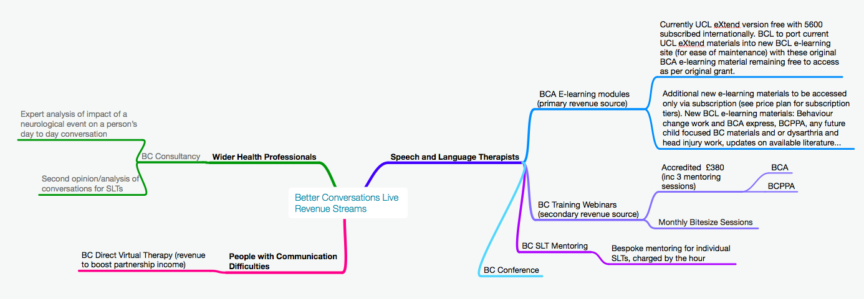

Figure . Price Plan

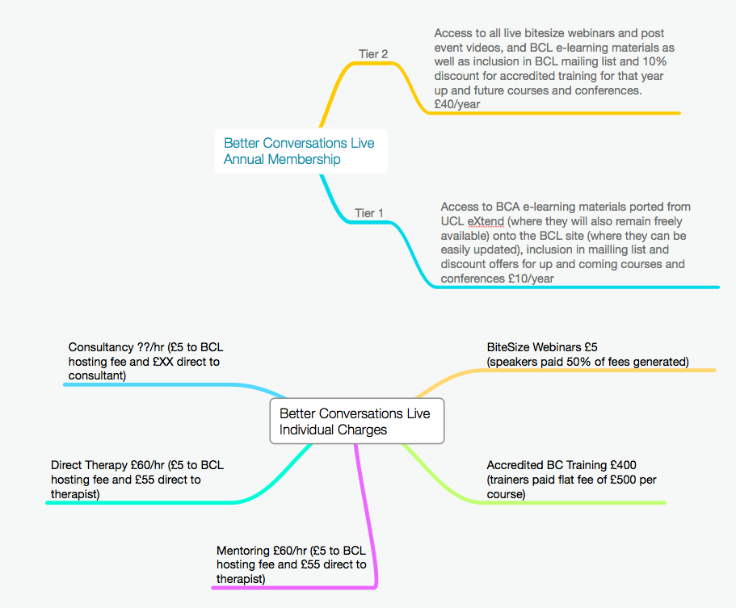

# Questions for Ana

1. What is UCL’s policy about IP in relation to our proposed business model, current version of BCA is on UCLeXtend (<https://extendstore.ucl.ac.uk/product?catalog=UCLXBCA>)?
2. How do we insure research integrity of the BC work?
3. We want to be a social enterprise but do you have any suggestions about the company structure? Different members of the team have different interests and time they can allocate to this business- how do we work out the best model to suit everyone?
4. Do you have any advice about different options for funding our business initially?
5. Do you have any contacts/pathways we can use to access other specialist knowledge we would need to start this business e.g. e-learning, web development contacts?